CS/EE 120B

Custom Project: RGB-HSV Tool

Jonas Sorgenfrei

Mai 30, 2018

# Introduction

The general idea of this project is based on different color models.

The user can enter any RGB Value on the LCD with the help of a keypad.

The entered value will be converted in PWM values and then the PWM will be used to dim the 3 color Pins of some RGB LEDs.

Since the ATmega has only 3 timers (which can be used) [general Timer, PWM(2channels), SPI connection with monitor], I use a second Microcontroller for the 3 PWM channel.

The TFT Screen will display the HSV Color circle and shows a black point where on the circle the current entered color is.

# Components (Pin-out)

* **Inputs**
  + Keypad (PORTA)
* **Outputs**
  + RGB LEDs (PORTD)
    - RED PORTD6 (second Atmega)
    - GREEN PORTD6
    - BLUE PORTD7
  + LCD-Display (PORTC)
    - Control (PORTC2-3)
    - DATA (PORTC4-7)
  + TFT Touch Screen (PORTB)
    - SCK PORTB7
    - SDA PORTB5
    - A0 PORTB3
    - Reset PORTB2

# 

# Complexities/Build-upons

1. Using the 16x2 LCD in 4 pin mode with custom characters

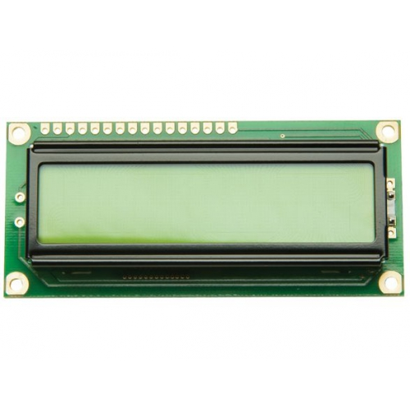

1. Using an TFT touch LCD Module for output using SPI as connection



1. Using RGB LEDs with PWM

